

**COMP 9900 Computer Science Project / Info Tech Project**

**Meal Recommendation System Final Report**

**W18Q-Commercialize**

Scrum Master student ID Email

Boyun Huang z5342276 z5342276@ad.unsw.edu.au

Group Members student ID Email

Qing Deng z5348431 z5348431@ad.unsw.edu.au

Sijie Liu z5329422 z5329422@ad.unsw.edu.au

Ruijie Ge z5277454 z5277454@ad.unsw.edu.au

Zequan Ding z5327869 z5327869@ad.unsw.edu.au

Final Report submission date: 2022/11/17

Contents

1 Background 1

1.1 Background 1

1.2 Meal Commercialize introduction 1

2 System Architecture 1

2.1 System Design 1

2.2 Deployment View 2

2.3 Model View 2

2.4 Data View 4

3 Functionalities Mapping 5

3.1 Eight Basic Functionalities 5

3.1.1 Creation & Maintenance of Profiles 5

3.1.2 Maintenance of Recipes 5

3.1.3 Convey of Opinion 5

3.1.4 Searching Functions for Recipes 5

3.1.5 Details of Recipes 5

3.1.6 Subscription Functions 5

3.1.7 Sorted Recipe News Feed 5

3.1.8 Recommendation System 5

3.2 Novel Functionalities 5

3.2.1 Real-time Chat System (Including Notifications & User Accessibility) 5

3.2.2 Reply to Comments 6

3.2.3 New Posting Hint with Red Dot (Subscribe Btn.) 6

4 System and Feature Walkthrough 6

4.1 Login Page 6

4.2 Register Page 7

4.3 Forget Password Page 8

4.4 Browse As a Guest 8

4.5 Explore Page 9

4.6 Recipe Detail Page 11

4.7 Chat Function 12

4.7.1 Chat directly with contributors 12

4.7.2 Check recent conversations 13

4.7.3 Chat with other users 13

4.8 Search Page 15

4.8.1 Search by keywords 15

4.8.2 Search by recipe type 17

4.9 Create recipe Page 18

4.10 Edit recipe Page 20

4.11 Subscribe Page 21

4.12 Profile Page 21

4.13 Edit Information Page 22

4.14 Reset Password Page 23

5 Future Feature Roadmap 23

5.1 Community Setup 24

5.2 Third-Party Login In and Sign In Support 24

5.3 Coursera Like Module and Video Support 24

6 Implementation Challenges 24

6.1 Front End 24

6.1.1 Page hopping issues 24

6.1.2 Page recreating issues 24

6.1.3 Broadcast 25

6.1.4 Add new items to a view 25

6.1.5 Screen adaptation of different sizes issue 25

6.2 Database 25

6.2.1 News feed notification 25

6.2.2 Asynchronous query 25

6.3 Virtual Machine 26

6.3.1 JavaWuzzy 26

7 Third-party Functionalities/Frameworks 26

7.1 Platform 26

7.1.1 Firebase 26

7.2 Front End 27

7.2.1 Navigation 2.5.0 27

7.2.2 RecyclerView 1.0.0 27

7.2.3 CardView 1.0.0 27

7.2.4 MultiDex 2.0.1 27

7.2.5 FirebaseUI 8.0.1 27

7.2.6 Rounded ImageView 2.3.0 28

7.3 Back End 28

7.3.1 Local binary dependency 28

7.3.2 Firebase Android Bom (Bill of Materials) 30.4.1 28

7.3.3 Firebase SDK for Google Analytics 28

7.3.4 Firebase SDK for Cloud Messaging 20.1.0 28

7.3.5 Retrofit 2.9.0 29

7.3.6 JavaFuzzy 1.4.0 29

8 System Setup Documentation 29

8.1 How to install 29

8.1.1 Adjust the view of the virtual screen 29

8.1.2 Installing Anbox on the Lubuntu 20.4.1 LTS 30

8.1.3 Installing our application 33

8.2 Run the application 35

8.3 IMPORTANT NOTE 35

9 Reference 37

# Background

## 1.1 Background

The development of the Internet in the past decade has enabled people to obtain more information through the Internet, bringing convenience to people around the world. When people dine in a restaurant, they may worry about food safety (including the freshness of food materials) and the potential risk of infection with COVID-19 in crowded places. In addition, eating in a restaurant usually costs more than cooking at home. In contrast, cooking at home is more economical, safer, and a perfect way to cultivate hands-on skills and creativity. Therefore, it is necessary to provide a platform for cooking enthusiasts to support them to obtain various recipes.

## 1.2 Meal Commercialize introduction

Meal Commercialize is a recipe recommendation application where users can find a large number of recipes and communicate directly with recipe contributors. Our project aims to develop a community for users, where explorers can get the content of recipes they are interested and contributors can upload some brilliant recipes they created. As a platform, it enables contributors to upload recipes, guide other users to successfully master new recipes, and interact with other users. Excellent recipes will bring more followers to contributors. On the other hand, it helps explorers find the recipe information they need, communicate with contributors, and other basic functions.

Most of the tasks set in the proposal document have been met, but we have also encountered some technical and other issues. Fortunately, these problems were solved with the guidance of the course staff and the reference of relevant literature by team members.

The project was divided into three sprints at Jira, with the first and third sprints consisting of approximately two weeks of development, testing, and deployment activities, while the second sprint lasted nearly three weeks. At the end of each sprint, we will conduct regular project demonstrations with supervisors and incorporate feedback to improve the results of the project.

The team also formed a WeChat group for weekly meetings and used GitHub for source code versioning.

# 2 System Architecture

## 2.1 System Design

This project is application-based with a demo deployed on Android Studio using java as programming language.

The front end of this application develops using XML (using PULL and SAX to resolve) and PNG sets (for special icons). Meanwhile, Android SDK and Gradle are used to resolve the dependency. Android Studio supports different type of Layouts and other drawable widgets.

For the back end, the business layer contains several sub systems including News Feed System, Search Function, Recipe Management, User Chat, Recommendation System, Profile Management. The application also introduces javaFuzzy, Firebase CloudMessage, Firebase Auth to help with real time interaction.

In data layer, this project uses Firestore to help with manipulating all the data.

All components could be deployed on a standard Android OS (test case uses pixel 5). You can also test it in a standard Android Studio Work Station after synchronizing.

## 2.2 Deployment View

Operating System: Android 11.0

Phone: Pixel 5 | Google APIs | x86

Android Plugins Version:7.2.1

## 2.3 Model View

The system is developed under MVC model.

Three types of user: explorer, contributor and guest. Guest and explorer are limited in some module.

For component in business layer, they are all written in Java, for layout and manifests, XML helps to handle all the pages and activate the relation between activity and layout.

Firestore are used for database access. Firebase CloudMessage and Firebase Auth interacts with front end to implement functions (emails register support and message transaction support).

Finally, after manipulate data, the application would adapter data gained from database and renders views for users.

The architecture graph is shown below:

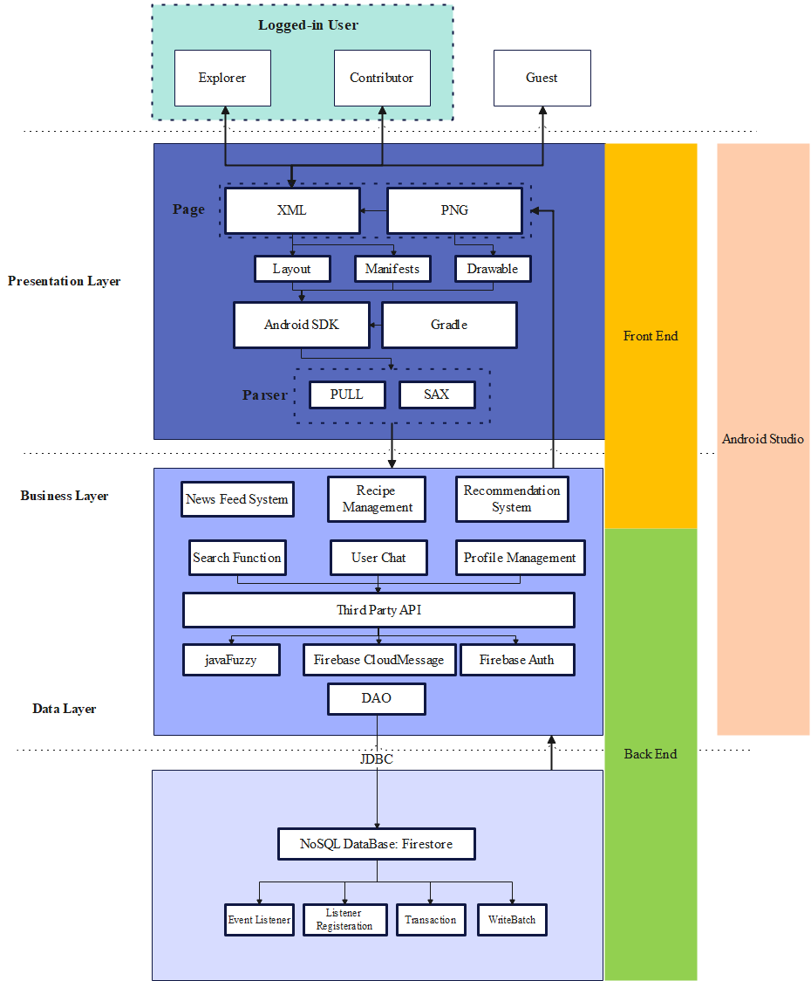

## 2.4 Data View

The system use Firestore as database which is an extendable NoSQL database. The system has 9 basic collections.

Below JSON tree shows the data structure of the system.

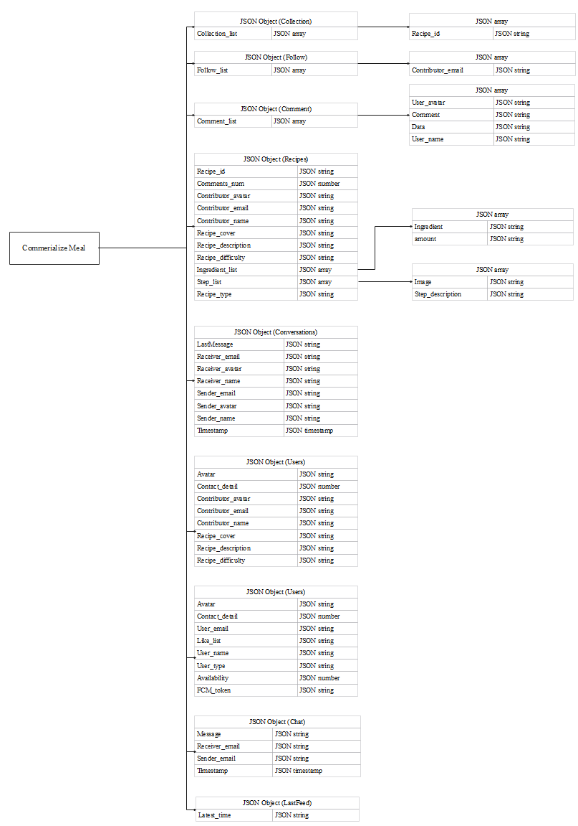

# 3 Functionalities Mapping

## 3.1 Eight Basic Functionalities

### 3.1.1 Creation & Maintenance of Profiles

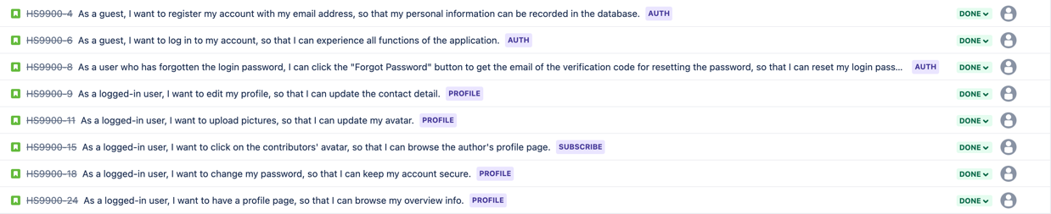

### 3.1.2 Maintenance of Recipes



### 3.1.3 Convey of Opinion



### 3.1.4 Searching Functions for Recipes



### 3.1.5 Details of Recipes



### 3.1.6 Subscription Functions

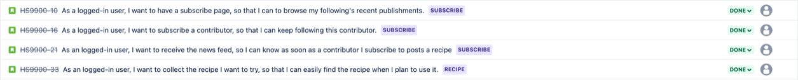

### 3.1.7 Sorted Recipe News Feed



### 3.1.8 Recommendation System



## 3.2 Novel Functionalities

### 3.2.1 Real-time Chat System (Including Notifications & User Accessibility)



### 3.2.2 Reply to Comments



### 3.2.3 New Posting Hint with Red Dot (Subscribe Btn.)



When the new contents posted by subscribed contributors are added to the subscribe page, without looking the new content by explorers, a red dot will appear on the upper right corner of the subscribe button to hint the user.

# 4 System and Feature Walkthrough

## 4.1 Login Page

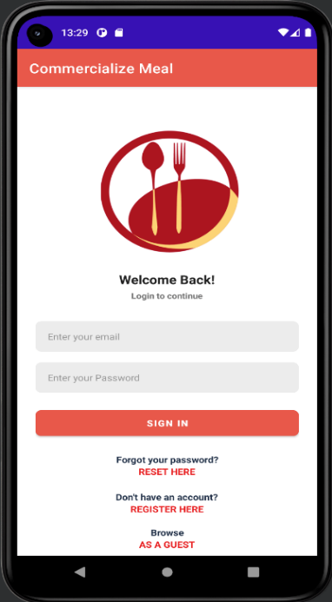

If a new user first time opens the Commercialize App, he/she will stay at the login page. If the user wishes to create a new account, he can click on the button 'Don't have an account? REGISTER HERE' on the screen below and jump to the register page.

If the new user doesn't want to create own account and keeps browsing in the application, the user can click on the button 'Browse AS A GUSET' and navigates him to experience the parts of the application's functions.

If the user has already had the account and forgets his password, he can click on the button 'Forgot your password RESET HERE' on the screen below and reset his password by the instruction.

If the user has already had the account and provided the correct email & password, by clicking on 'SIGN IN' button, he can experience all functions of the application.

## 4.2 Register Page

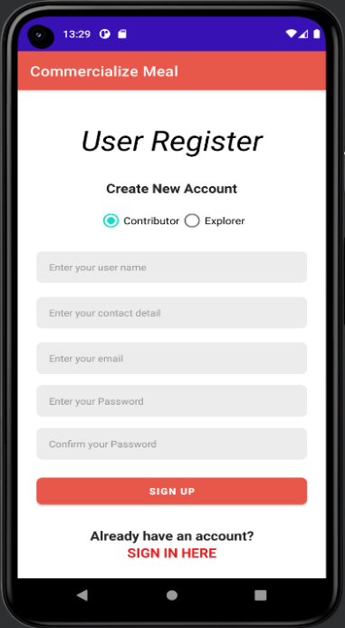

After clicking on the button 'Don't have an account? REGISTER HERE', the user will come to the register page. By providing the corresponding information correctly such as the account type, username, contact detail, email address, password, confirmed password and clicking on the 'SIGH UP' button below, a new account will be created and all the account information’s will be automatically stored in the Firebase.

The difference between two account types is the contributor can publish new recipe, but the explorer can't commit that. There is no limitation for the username and the contact detail. The email address should follow the standard email format, the password should be at least six characters, the confirmed password should correspond with the password, and all the blanks should be filled in. Otherwise, the error message will jump out to hint the user to improve his information.

If the user wants to give up registering, clicking on the button 'Already have an account? SIGN IN HERE' can help him jump back to the login page.

## 4.3 Forget Password Page

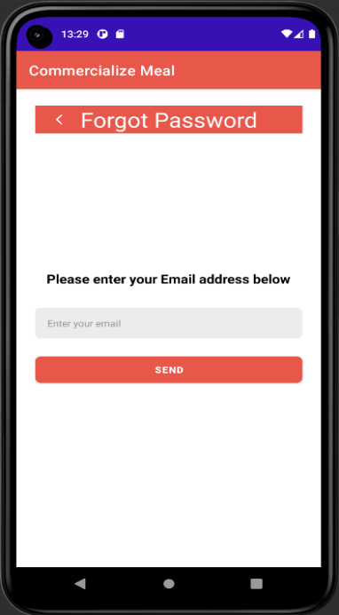

After clicking on the button 'Forgot your password RESET HERE', the user will come to the reset password page. By inputting the real existed email address and clicking on the 'SEND',

the user will get a notification in the email box. Just follow the instruction of the new received email to reset the email, the user can use the new password to login into the account.

## 4.4 Browse As a Guest

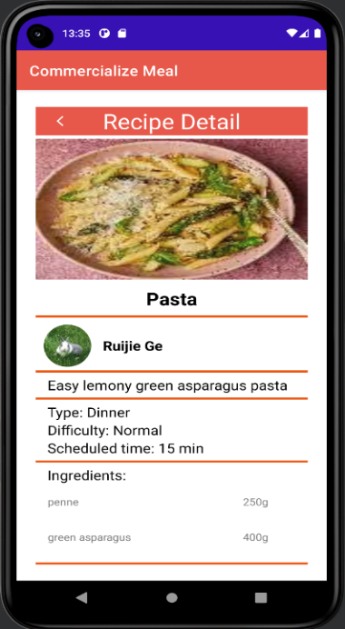 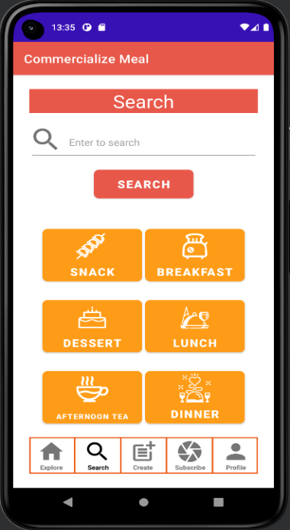

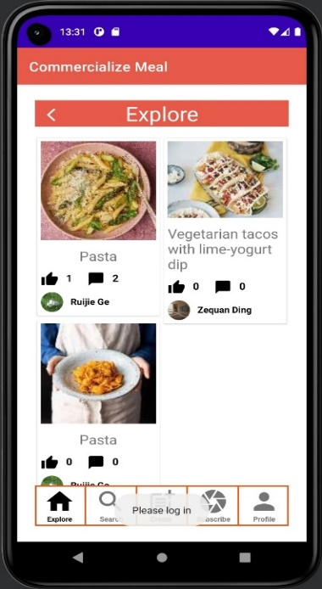 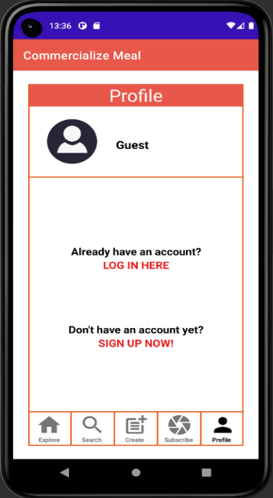

After clicking on the button 'Browse AS A GUSET', the user will come to the explore page as a guest. The only functions enjoyed by guests are viewing the recipe details when he clicks recipes in the explore page or searching recipes, they interest in the search page. Guests cannot give thumb, collect, or comment to any recipe. They allow can't follow any contributor, or view any contributor's detail page. They cannot create own recipes, receive subscriptions because they can't follow people, and when they click the buttons 'Create' & 'Subscribe', guests will get the hint that they do not have accounts yet. Guests also cannot chat to anyone and do not have a profile to record details. In a word, the guest experience is not so good because of the lack of access, until he clicks on the profile button and realize that it's necessary to create an account. That's the reason why the button 'SIGN UP NOW!' appears in the profile page, which navigate the guest to create new account. The button 'LOGIN IN HERE' can help the user return to the login page.

## 4.5 Explore Page

Explore page aims to recommend recipes to explorers. To prioritize recipes that an explorer is most likely to be interested in, this page applies a special designed recommendation system. Our recommendation system is a collaborative filtering system, both users and recipes are considered. For those who are not logged in or newly registered, user-based rule is not used because no preferences of current user can be obtained. Therefore, only applying recipe-based rule: Rank recipes from highest to lowest in order of how many people like them. For an old user who has liked some recipes, both recipe-based and user- based strategies can be used. First, according to the like list of the current user, find the user A with the highest similarity to the current user's favorite list from the database (It is calculated as the intersection of two lists divided by the union of two lists). Then, recommend the first two recipes with the highest number of like num in the like list of user A. Recipe-based rule depends on the type of recipes. For all recipes in current user’s like list, count the types of recipes with the most occurrences, recommend the two most liked recipes in this category. The rest of the recipes are still ranked from most to least like num. Apart from that, if a recipe is collected by current user, the user can easily find it in his collection page, so the system will not recommend this recipe anymore.

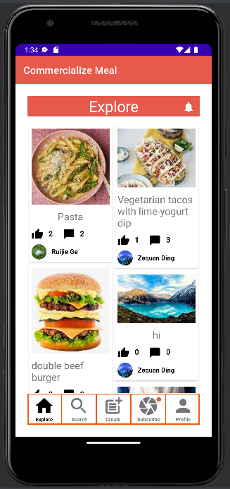

Different from the traditional page layout method of full alignment from top to bottom, left to right, our page layout is Masonry Layout. That means each recipe is of equal width but is of unequal height, recipes ranked at the top are higher. When an explorer slides the page up and down, he will not suffer from visual fatigue due to seeing the same layout for a long time. Therefore, it is an effective way to keep people focused on finding new recipes that interest them

If the explorer is not satisfied with the recommended recipes, he can move to the top of the page and pull down the page, then the page will refresh and move the top two recipes to the bottom and the next recipe to the top.

At the bottom of each recipe image are the number of likes and comments for that recipe. However, when going back to explore page, the page will not refresh automatically. Therefore, to get the latest data, manual refresh is necessary.

The bell button at the top can go directly to the chat interface.

## 4.6 Recipe Detail Page

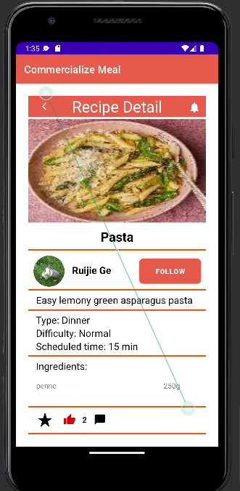

Click the image of any recipe will jump to the detail page of the recipe. In this page, all the main information for creating the recipe will be shown.

Apart from that, this page implements five main functions.

1. The explorer can follow the contributor of this recipe. After following this contributor, the explorer can get the latest information of the contributor. If the explorer has liked the recipe, the button will be red.

2. The explorer can click thumb-up button to like the recipe, the more likes one recipe get, the more popular it becomes. If the explorer has collected the recipe, the button will be yellow. The number next to the thumb-up button show the number of likes the recipe has get.

3. The explorer can click pentagram button to collect the recipe. After that, the explorer can quickly and easily find the recipe by checking his collection page.

4. If the explorer wants to publish some ideas for recipes, he can click the comment button and put some comments there. As the contributor wants to response to the comment, he can also comment the response given by others.

5. If the explorer wants to know more about the contributor, he can click the avatar of the explorer and the page will jump to contributor’s personal homepage.

## 4.7 Chat Function

### 4.7.1 Chat directly with contributors

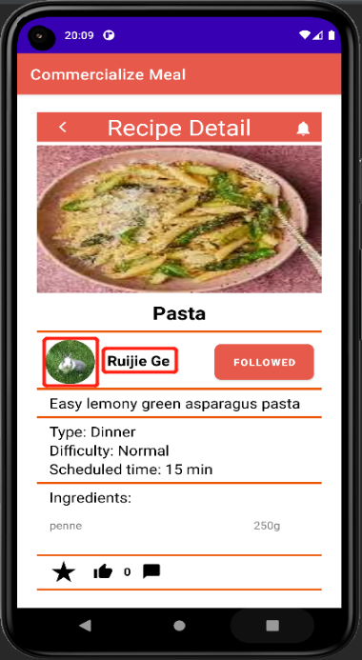 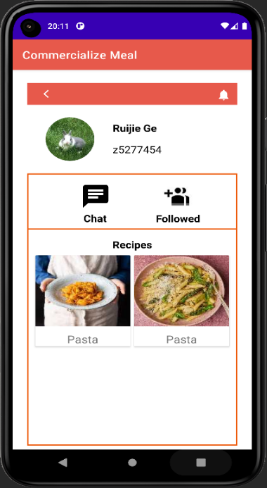

If a logged-in user wants to communicate directly with a contributor after browsing a recipe, he can simply click the contributor's avatar or username to enter his profile page. The profile page also shows all recipes this contributor has published, so the user can check out what other recipes they are interested in.

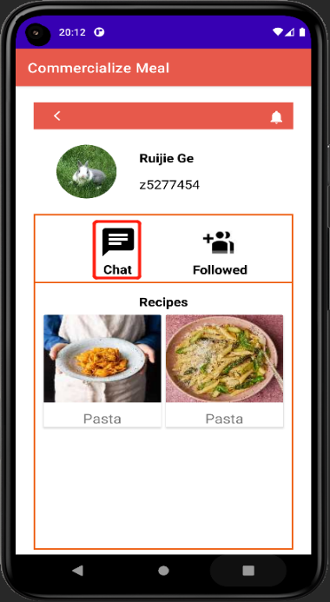 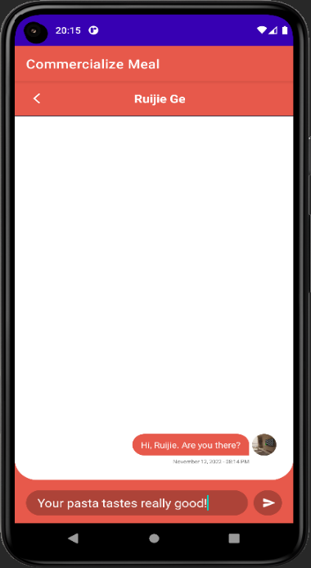

On this page, click "Chat" button, and you can enter the page of live chat. On this page, you can send text messages to this contributor. In this way, you can almost discuss everything with the contributor. For example, some steps in cooking a particular recipe are not clear enough, and you want quicker response from the author, in this case you can simply chat with him to save time. This function is also suitable for people who do not want to leave a comment to recipes for privacy concern because the conversation between them and an author is private and cannot be seen by other users. However, if you want to chat with an explorer, you must search this user on another page of chatting function. This is because an explorer is not able to publish recipes, thus you cannot find him via a particular recipe.

### 4.7.2 Check recent conversations

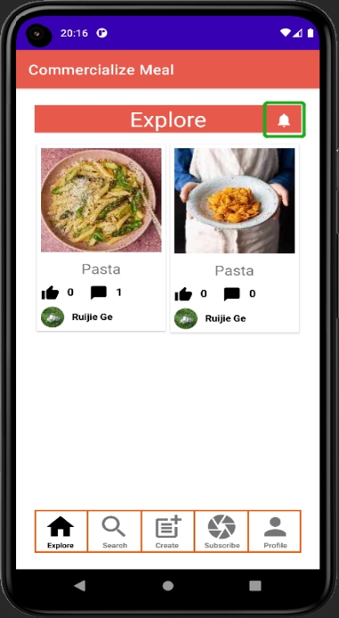 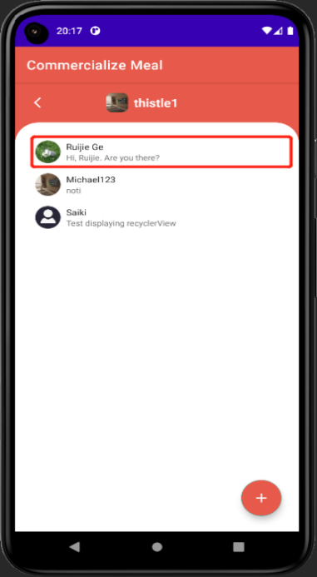 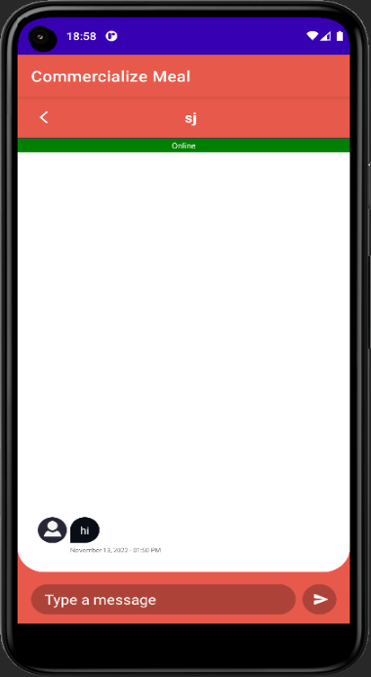

Go back to the main page of the App. If a user wants to check his recent conversations with others, he can click the bell icon on the upper-right corner to enter the "recent conversations" page. On this page, all users you have chatted with are listed, and you can click any of them to start to chat again. If the user you are chatting with is using the chatting function (have at least entered the "recent conversations" page), a green bar with a notification of "Online" will appear on the page of typing messages.

### 4.7.3 Chat with other users

In order to improve the sense of participation user could chat with anyone in the community directly. User could press chat icon in profile page and they will be redirected to chatting page. User could click the plus icon to select a user to start a new conversation.

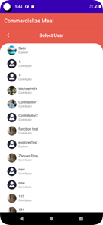

After user select them. Page will be redirect to live chat page and their historical chatting information will be shown if exists. Then user could input message in the bottom input text to chat.

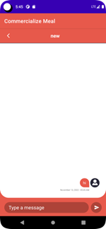

## 4.8 Search Page

### 4.8.1 Search by keywords

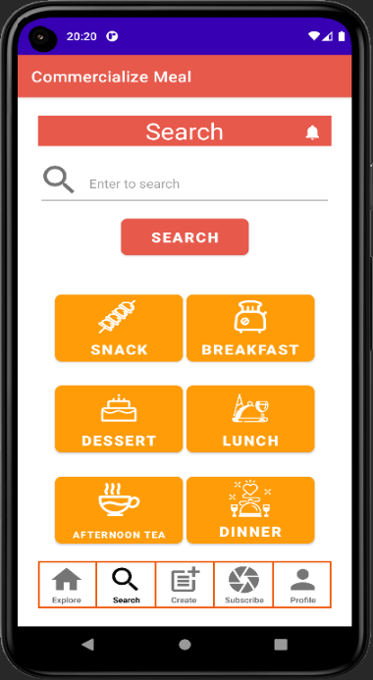 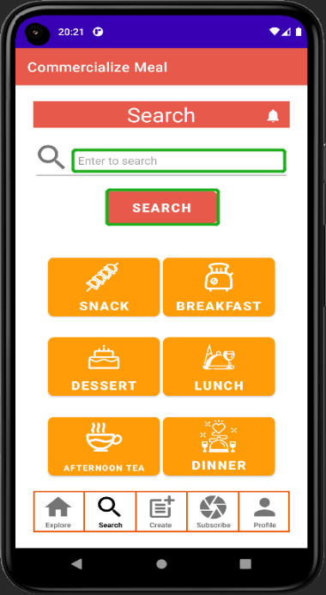 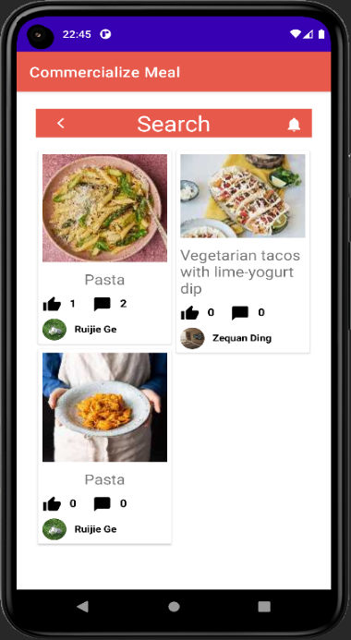

A logged-in user may want to search for desired recipes by one or more characteristics of the recipe, so that the results he gets will be more in line with his requirements. On the 'Search' page, he has two options: to search using keywords or to search by a recipe's type. First, we introduce searching based on keywords. Input anything you like into the search bar and click 'SEARCH' button, and it will lead you to the result page. If the input is empty, then the result will show all recipes in the database in descending order of the number of 'Likes'.

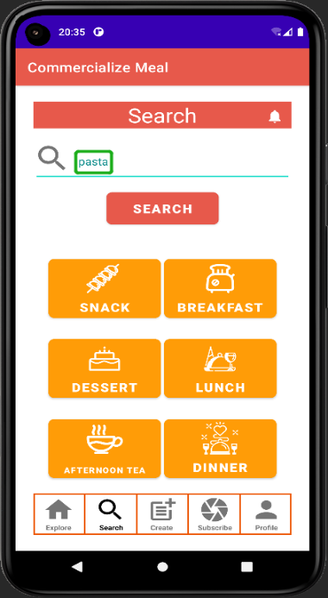 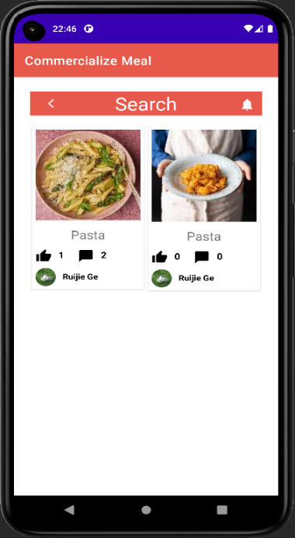

If the input is not empty, the App will try to match the content of input with the title of a recipe, the contributor's username, or the brief description of a recipe. To implement this, we introduced a third-party library named JavaWuzzy, which is able to calculate a matching score between two strings using Levenshtein Distance algorithm. If any of them has a matching score higher than 90, then this recipe will be included in the result. In this case, we search 'pasta' and get two results whose title contains 'pasta'.

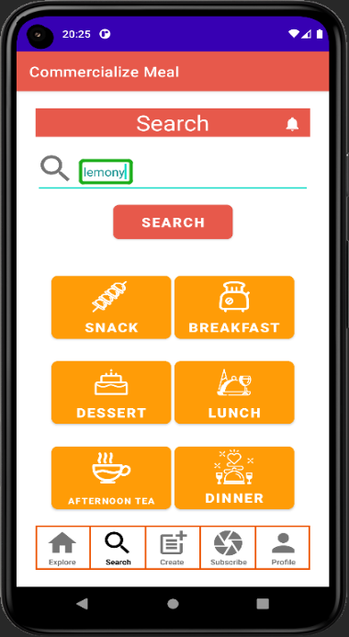 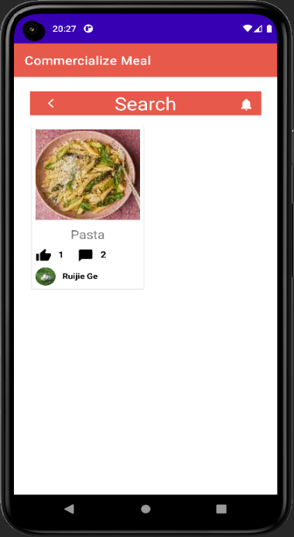 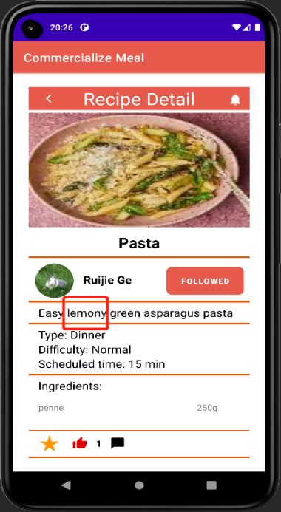

If we search 'lemony', then we only get one related result. Check its detail, we find that the description of this recipe contains the word 'lemony', thus the searching result is reasonable.

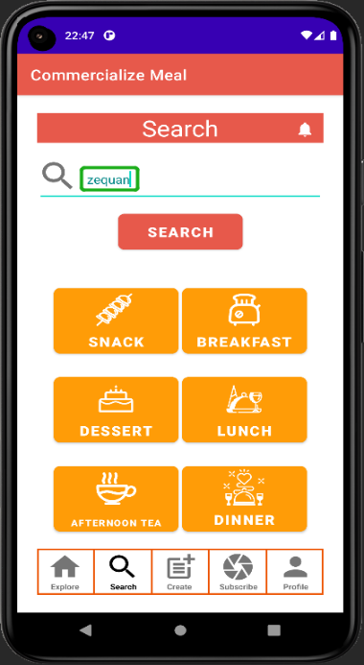 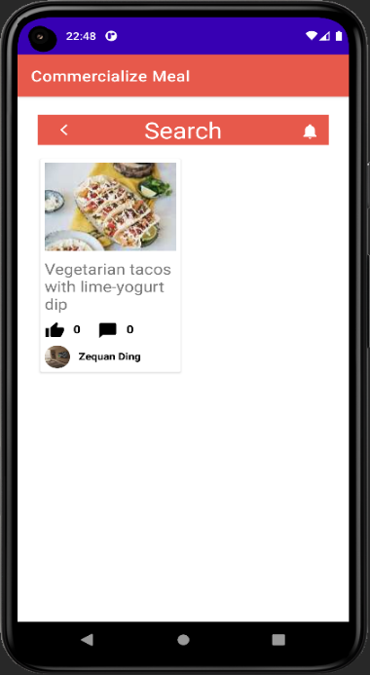

Then, we try to search with a contributor's username (e.g. zequan). And we can find all recipes published by Zequan Ding.

### 4.8.2 Search by recipe type

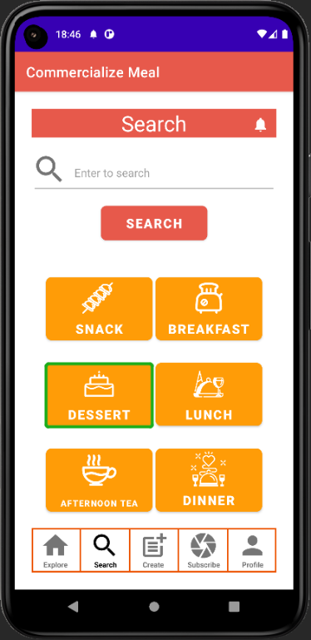 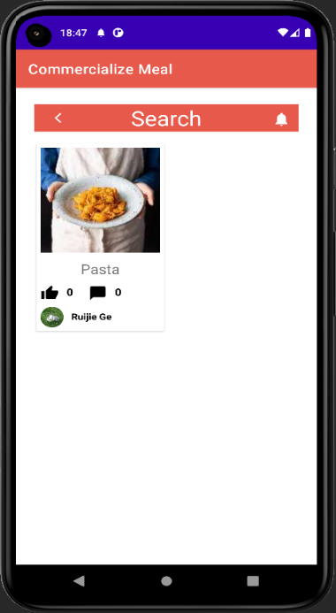 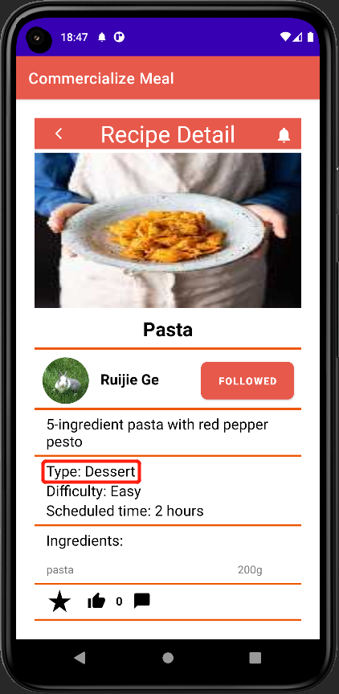

Then we try to search by a recipe's type. For example, we click the 'DESSERT' button, and get one result. Click on it to see its detail, and we find its type is indeed 'Dessert'.

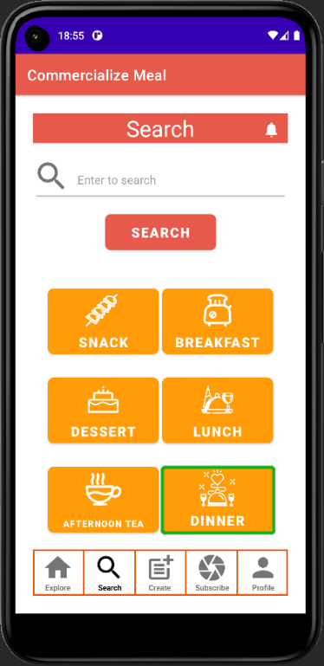 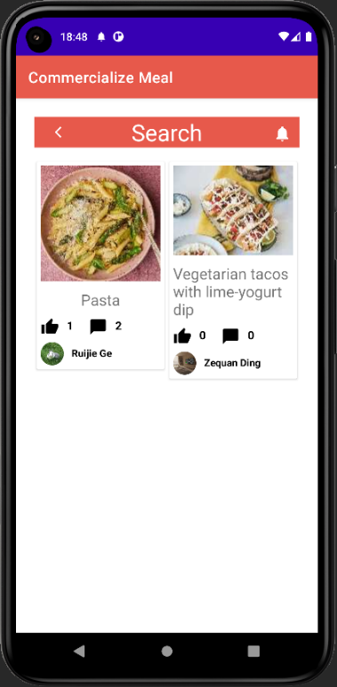

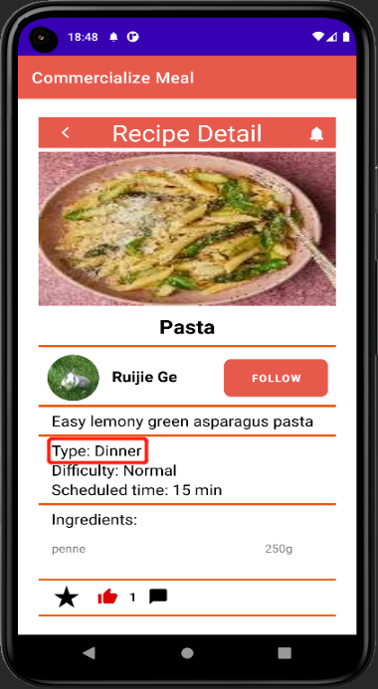 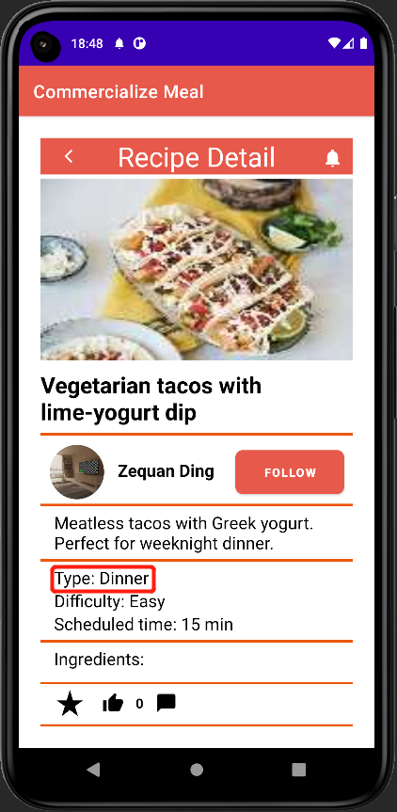

Go back to 'SEARCH' page, click the 'DINNER' button, and we get two results. Click on them to see their detail, and we find their type is indeed 'Dinner'.

## 4.9 Create recipe Page

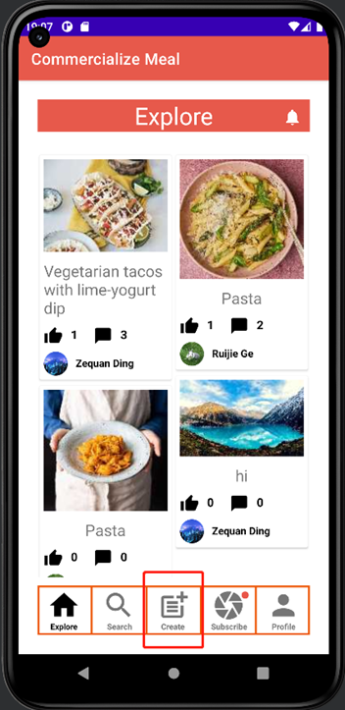 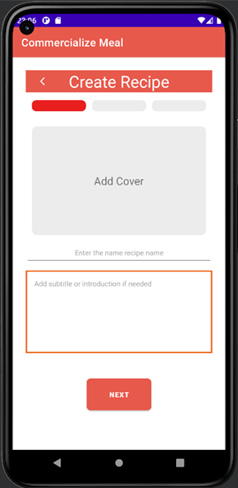

Contributors have the authority to upload their recipes to the app for explorers to browse and learn, while explorers cannot publish recipes.

Click the “Create button” in the middle of the bottom navigation bar to jump to the Create Recipe Page. Contributors will first need to add a cover image to their recipes, then set a title for their recipes, and add some attractive descriptions. If a contributor forgets to add a cover image, title, or description to a recipe, an error message will appear at the bottom of the page asking the contributor to provide the appropriate missing content.

Clicking the “Next” button will take you to the second step of creating a recipe, where contributors will enter all the ingredients and seasonings needed for the recipe.

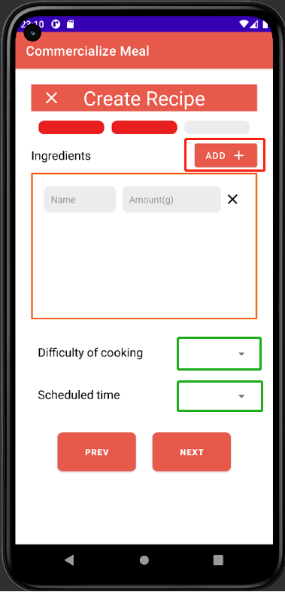

Each click of the add button will create a new entry, and each entry will need to enter an ingredient or seasonings and the corresponding quantity. Once all the ingredients have been added, the contributors need to select the cooking difficulty and how long it will take. If the contributors do not want to publish the recipes halfway, they can also click the “X” button in the upper left corner of the page to return to the home page, and they can also return to the previous step by clicking the “Previous” button. Again, if the contributor does not provide ingredients, cooking difficulty, or cooking time, an error message will prompt the contributor to complete the content.

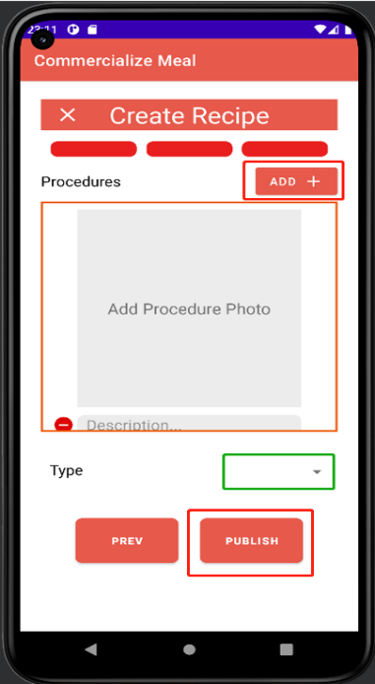

The final step of creating a recipe is to upload the detailed process of each step with pictures and text.

Contributors can add steps to the recipe by clicking the “Add” button. They will be asked to upload a picture with a caption each time they click the “Add button”. If the contributor wants to delete the redundant steps, they can also click the subtraction icon to delete them. Finally, contributors will need to choose a category for the recipe from “Breakfast, Lunch, Dinner, Snack, Dessert, Afternoon Tea”.

## 4.10 Edit recipe Page

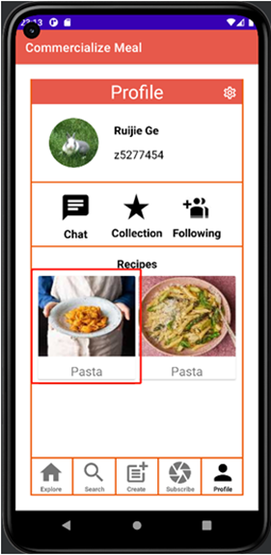 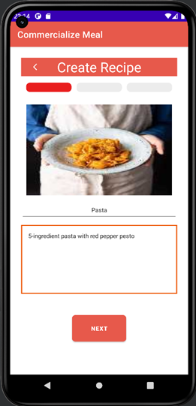

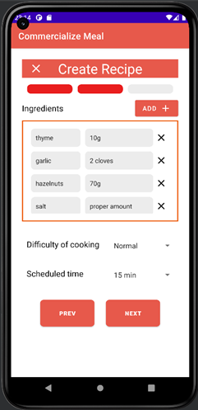 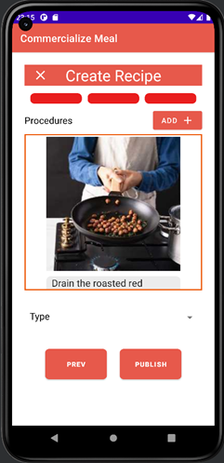

Contributors can go to the Recipe Editing Page by clicking on the thumbnail of their published recipe which is displayed on the Profile Page. The Editing Recipe Page layout is the same as the Creating Recipe Page, but the contents of the Editing Recipe Page will automatically reference the latest modified version. When editing is complete, clicking the Publish button will update the contents of the recipe. Please note that contributors need to select the cooking difficulty, duration, and classification for the dishes again.

## 4.11 Subscribe Page

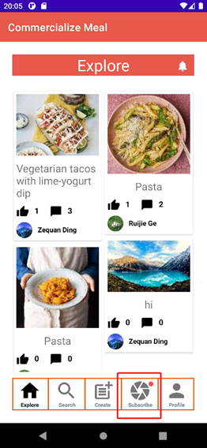 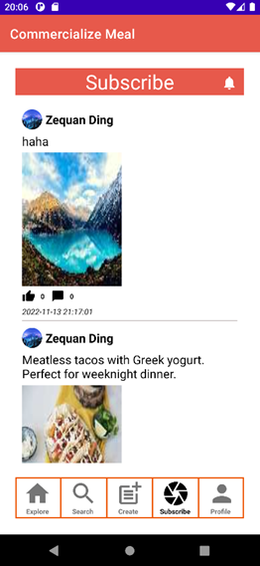

Explorers can subscribe to their interested contributors. Click the subscribe icon in the bottom navigation bar will hop to the Subscribe Page, which displays the latest updates from all the contributors the explorer follows. And the content displayed on the page will be arranged in chronological order, with the latest release at the top. Every moment displayed on the subscribe Page will include the recipe cover, the profile and user name of the contributor, as well as the number of likes and comments. The explorer can enter the recipe detail page by clicking the recipe thumbnail. Each time a contributor modifies a recipe or posts a new one, followers receive a news feed in the form of a small red dot that appears in the upper right corner of the subscribe icon in the bottom navigation bar.

## 4.12 Profile Page

After user logging in, users are able to browse their profile page which contain their overview information by clicking the navigation bar below. They could also check notice, collection and followers. At the bottom part, user could view recipes they had post before.

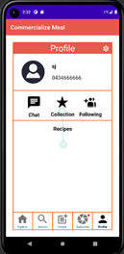

## 4.13 Edit Information Page

User could click the setting icon to edit their profile for example, avatar and contact information.

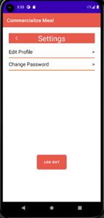

By pressing the Edit Profile text line. User will be navigated to edit profile page, they could click the avatar to change a new one or change the username or contact email. After user input their new information. They could click the Save button to submit changing request.

Note that user could not input empty text to save.

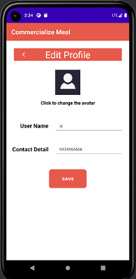

## 4.14 Reset Password Page

User could also click the Change Password text line to change their password. After clicking the text line, they will be redirect to change password page. The rule of reset password is enter current password to authenticate enter and confirm new password to continue. After clicking set button. User will be able to change their password.

Note that user is not allowed to set the same password and has a limitation of at least 6 characters long.

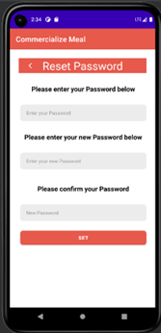

# 5 Future Feature Roadmap

## 5.1 Community Setup

For a user-friendly application. It is import to create different community in the app. This would provide user access to focus more on their interesting topics. At the same time, this would tighten the bridge between users.

## 5.2 Third-Party Login In and Sign In Support

This would provide user with better experience when sign in or login up. User could sign in or up directly with Google or Meta account. This could also get their friends in real life if they want.

## 5.3 Coursera Like Module and Video Support

In the future, this app could hold online video courses for contributors to teach users how to cook accurately. Contributors could also upload video for each recipe.

# 6 Implementation Challenges

## 6.1 Front End

### 6.1.1 Page hopping issues

The Android SDK provides developers with a finish() method to destroy the current activity (page). However, it is much more complicated to destroy an activity you are not viewing. In other words, finding activities that are running backstage is hard. For example, there are three steps creating a recipe, and an user may cancel creating in the third step. In this case, activities of step one and two should be destroyed, otherwise there is possibility that the user can go back to pages which are not supposed to be there (using the back button provided by the Android navigation bar).

Solution:

We finally find two common ways to solve this problem.

1. Declare a variable of activity A in its own onCreate method. Then create an instance for this variable in another activity, and use the finish() function to destroy it.
2. Create a collection of activities to manage. This needs to create a ActivityCollector class, and implement addActivity() and removeActivity() methods.

Since we only need to destroy at most two activities running backstage, there is no need to use solution two. Thus, we finally make use of solution one.

### 6.1.2 Page recreating issues

Similar to the last issue, we face a problem that a user may want to go back to step 2 when he is in step 3 to check some things he just input. Android SDK provides startActivity(intent) method to go to another activity, but by default it will create a new instance of the activity instead of entering the older one. Thus, the old instance with info an user has just input will be lost for good. And user have to input some content again.

Solution:

To solve this, we find we can change the launch mode of an activity via the Manifest.xml file. When it is changed to ‘singleInstance’, this activity will be created only once until its finished() method is used. Thus, we are able to enter the same page for many times.

### 6.1.3 Broadcast

When implementing the function of following someone, we face a problem about how to pass information between activities. For example, there is a ‘Follow’ button in page A, page A has an entry to page B, and there is also a ‘Follow’ button on page B. When an user click ‘Follow’ in page B, it changes to ‘Followed’, and the button on A should become ‘Followed’ as well at this time. Besides, page B cannot be closed at this time. So using putExtra() directly to store this status information and transfer it back to page A is not feasible.

Solution:

We need to define and intantiate a broadcastReceiver in page A. After we store status information using intent.putExtra() method in page B, we broadcast it back to page A. When A receive the broadcast, it can decide whether the button should be ‘Follow’ or ‘Followed’.

### 6.1.4 Add new items to a view

Until this project, all view widget we have used can load data automatically, because the size of an array is known. But now, we want to add or delete a particular row in a view when clicking ‘Add’ button or the [subtraction](https://dict.youdao.com/w/subtraction/#keyfrom=E2Ctranslation) button.

Solution:

Override the onClick method of for the view widget. Write an addView method and set on click listener to define what will happen when ‘Add’ button or the [subtraction](https://dict.youdao.com/w/subtraction/#keyfrom=E2Ctranslation) button is pressed.

### 6.1.5 Screen adaptation of different sizes issue

There are no issues found in the preview of the local machine, but it will be misaligned when running on the virtual machine. We found the control alignment standard is inconsistent, which may cause the content in different environments to display inconsistently. To solve this, we rechecked all layout constraints, and finally solve this problem.

## 6.2 Database

### 6.2.1 News feed notification

If one of your followings publish a new recipe, a red dot will appear on the ‘Subscribe’ button to notify you of news feed update.

Solution:

We have to store the publishment time of the latest recipe an user have viewed. And then we set an event listener to listen to changes in database when the APP is running. If the timestamp of a recipe published by any of his followings is later than this time, the red dot will appear.

### 6.2.2 Asynchronous query

Firestore is an asyncronous database. The time when a query is completed, the program may have executed on other lines of codes. This can cause null pointer exceptions. For example, the codes below may throw a null pointer exception because the time the system prints the content of string ***a***, ***a*** may has not been assigned with a value due to the incompletion of query.

String a;

firebaseFirestore.collection(MacroDef.KEY_COLLECTION_USERS).whereEqualTo(MacroDef.KEY_EMAIL, email).get().addOnCompleteListener(task1 -> {

if(task1.isSuccessful() && task1.getResult() != null &&

task1.getResult().getDocuments().size() > 0) {

a = task1.getResult().getDocuments().get(0).getString(“Username”);

}

});

System.out.println(a);

Solution:

Put successive codes into the addOnCompleteListener, below getResult() method.

## 6.3 Virtual Machine

### 6.3.1 JavaWuzzy

We used a third-party extension named Algolia to implement the searching function and it works fine on an emulator on Windows. But it crashes when I test it on VM using the Anbox emulator. This is probably because the version of Android of Anbox is too old. We have to find a substitution for Algolia.

Solution:

JavaWuzzy is an open-source library to provide fuzzy string matching function based on the Levenshtein Distance algorithm. We import it to achieve the search function for recipes.

# 7 Third-party Functionalities/Frameworks

## 7.1 Platform

### 7.1.1 Firebase

Firebase provides detailed documentation and cross-platform SDKs to help you build and ship apps on Android, iOS, the web, C++, and Unity. It can guarantee Apps running quickly & securely with fully managed backend infrastructure. In this project, we use the Firebase as our backend cloud database.

* **Firebase Authentication**

In this project, we use the Firebase Authentication’s API ‘FirebaseAuth’ to register for new users’ emails & passwords and to check the emails & passwords when users try to login into their account.

* **Firebase Firestore Database**

Firestore is a NoSQL document database built for automatic scaling, high performance, and ease of application development. While the Firestore interface has many of the same features as traditional databases, as a NoSQL database it differs from them in the way it describes relationships between data objects. In this project, we use the Firebase Firestore’s API ‘FirebaseFirestore’ to store object’s information in the database and chase & pull object’s information stored in database down to the local to use.

## 7.2 Front End

### 7.2.1 Navigation 2.5.0

**implementation 'androidx.navigation:navigation-fragment:2.5.0'**

**implementation 'androidx.navigation:navigation-ui:2.5.0'**

Navigation is a framework for navigating between 'destinations' within an Android application that provides a consistent API whether destinations are implemented as Fragments, Activities, or other components.

### 7.2.2 RecyclerView 1.0.0

**implementation 'androidx.recyclerview:recyclerview:1.0.0'**

RecyclerView can display large sets of data in the UI while minimizing memory usage. In our project, the reason to add this dependency is that RecyclerView implements a third party with many features such as drop-down refresh, scrolling to the bottom to load more and custom adding headers.

### 7.2.3 CardView 1.0.0

**implementation 'androidx.cardview:cardview:1.0.0'**

CardView can implement the Material Design card pattern with round corners and drop shadows. In our project, the reason to add this dependency is that CardView displays the boundaries between recipes and recipes and make the UI of the staggered grid layout clearer and more three-dimensional.

### 7.2.4 MultiDex 2.0.1

**implementation 'androidx.multidex:multidex:2.0.1'**

An android application program is compiled into a .dex file which in turn zipped to a single .apk file. The scenario for using it is when the application fails to compile due to hitting the 65,536 DEX methods(references) limit, the number of references can exceed 65,536 by going with multidex.

### 7.2.5 FirebaseUI 8.0.1

**implementation 'com.firebaseui:firebase-ui-database:8.0.1'  
implementation 'com.firebaseui:firebase-ui-firestore:8.0.1'  
implementation 'com.firebaseui:firebase-ui-auth:8.0.1'  
implementation 'com.firebaseui:firebase-ui-storage:8.0.1'**

FirebaseUI is an open-source library for Android that allows you to quickly connect common UI elements to Firebase APIs. It has separate modules for using Firebase Realtime Database, Cloud Firestore, Firebase Auth, and Cloud Storage.

### 7.2.6 Rounded ImageView 2.3.0

**implementation 'com.makeramen:roundedimageview:2.3.0'**

RoundedImageView is an open-source library for Android that supports many additional features including rounded corners, ovals, rounded rectangles, ScaleTypes and TileModes. There are many ways to create rounded corner in android, but this is the fastest ways because it:

* does **not** create a copy of the original bitmap
* does **not** use a clipPath which is not hardware accelerated and not anti-aliased.
* does **not** use setXfermode to clip the bitmap and draw twice to the canvas.
* RoundedImageView in the project help us shape the avatar of users to be round.

## 7.3 Back End

### 7.3.1 Local binary dependency

**implementation fileTree(dir: 'libs', include: ['*.jar'])**

Gradle declares dependencies on JAR files inside your project's module_name/libs/ directory (because Gradle reads paths relative to the build.gradle file).

### 7.3.2 Firebase Android Bom (Bill of Materials) 30.4.1

**implementation platform('com.google.firebase:firebase-bom:30.4.1')**

The Firebase Android BoM (Bill of Materials) enables you to manage all your Firebase library versions by specifying only one version — the BoM's version. When you use the Firebase BoM in your app, the BoM automatically pulls in the individual library versions mapped to BoM's version. **All the individual library versions will be compatible**. When you update the BoM's version in your app, all the Firebase libraries that you use in your app will update to the versions mapped to that BoM version. When using the BoM, you don't specify versions in Firebase library dependencies.

### 7.3.3 Firebase SDK for Google Analytics

**implementation 'com.google.firebase:firebase-analytics'**

The heart of Firebase is Google Analytics, which is an app measurement solution, available at no charge, that provides insight on app usage and user engagement.

### 7.3.4 Firebase SDK for Cloud Messaging 20.1.0

**implementation 'com.google.firebase:firebase-messaging:20.1.0'**

A service that extends FirebaseMessagingService. This is required if you want to do any message handling beyond receiving notifications on apps in the background. To receive notifications in foregrounded apps, to receive data payload, to send upstream messages, and so on, you must extend this service in Manifest.

### 7.3.5 Retrofit 2.9.0

**implementation 'com.squareup.retrofit2:retrofit:2.9.0'  
implementation 'com.squareup.retrofit2:converter-scalars:2.9.0'**

Retrofit is a REST Client for Java and Android allowing to retrieve and upload JSON (or other structured data) via a REST based You can configure which converters are used for the data serialization. To work with Retrofit, basically here need the following three classes:

* Model class which is used as a JSON model
* Interfaces that define the possible HTTP operations
* Retrofit.Builder class - Instance which uses the interface and the Builder API to allow defining the URL end point for the HTTP operations.

In the project, we use retrofit’s APIs to build interface for clients and to achieve chat message notification, if users don’t stay in the chat system, and use a green bar at chat page top to detect user’s accessibility.

### 7.3.6 JavaFuzzy 1.4.0

**implementation 'me.xdrop:fuzzywuzzy:1.4.0'**

Java Fuzzy is an open-source library to provide Fuzzy string matching function based on the FuzzyWuzzy Python algorithm, which uses Levenshtein distance to calculate similarity between strings. In this project, we import Java Fuzzy to use its API to achieve the search function for recipes.

# 8 System Setup Documentation

The application is tested on a virtual machine based on the Lubuntu 20.4.1 LTS.

## 8.1 How to install

Our application runs on an Android emulator named Anbox. Anbox is an Android emulator that is available for any GNU/Linux operating system.

Tip: text starts with $ is a command line statement, and it requires to be executed in the terminal of the Lubuntu.

### 8.1.1 Adjust the view of the virtual screen

Power on the virtual machine, make sure the view of the virtual screen is normal (resized to the maximum resolution of your monitor). If it does not look like the screenshot below, please power off the virtual machine and restart it.

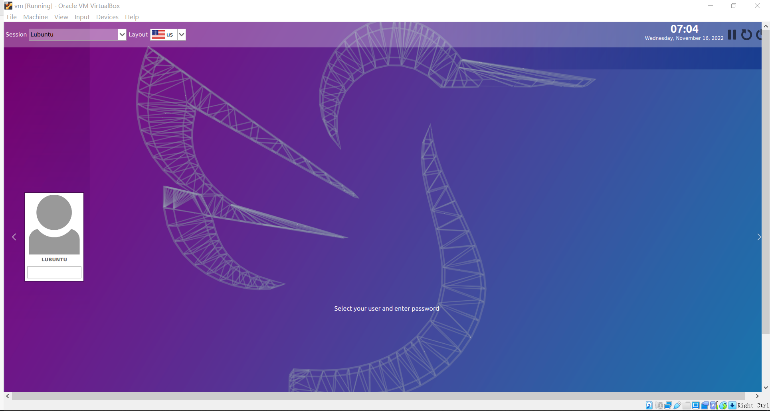

When it is starting, immediately click the ‘View’ button in the navigation bar of the VirtualBox on the upper-left corner, then click ‘Virtual Screen 1’ -> ‘Scale to 125%(autoscaled output)’. And wait for several seconds until you see what is like the image below.

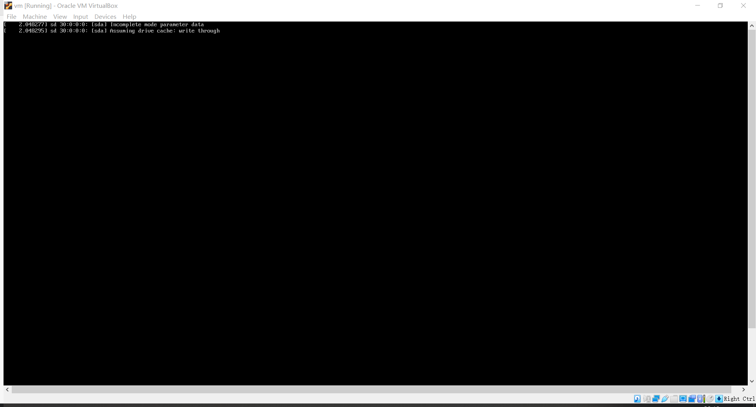

Now, click ‘View’->‘Virtual Screen 1’->‘Scale to 100%(unscaled output) and ‘View’->‘Virtual Screen 1’->Resize to 1920x1080. Then your view should be normal like the first image above. The next time your start the virtual machine, you should not need to repeat these steps to adjust the size of the view.

### 8.1.2 Installing Anbox on the Lubuntu 20.4.1 LTS

Open the terminal, execute following commands:

$sudo apt-get update

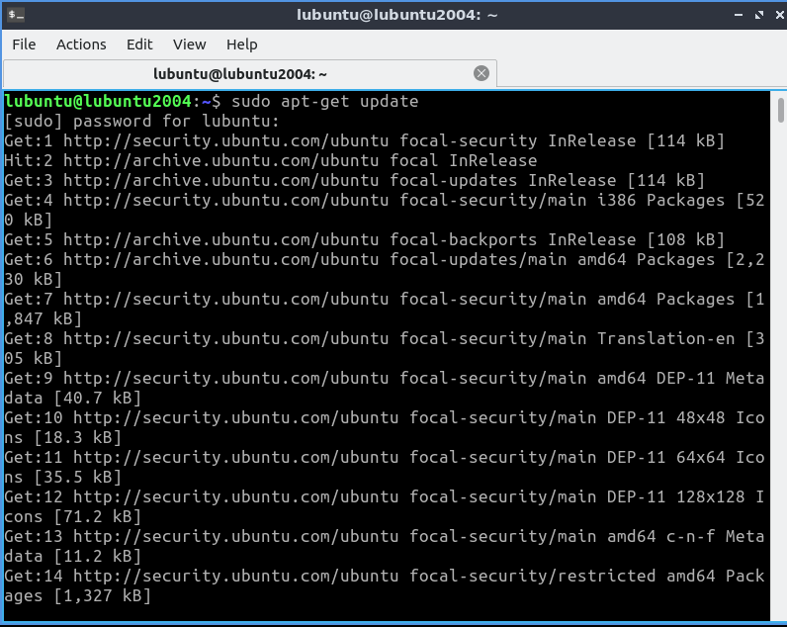

$ sudo apt install dkms linux-headers-generic

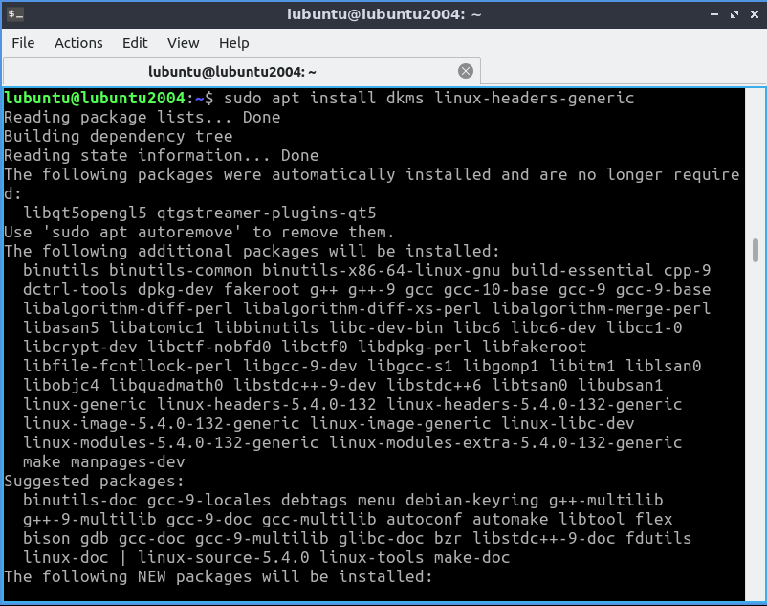

$ git clone https://github.com/anbox/anbox-modules.git

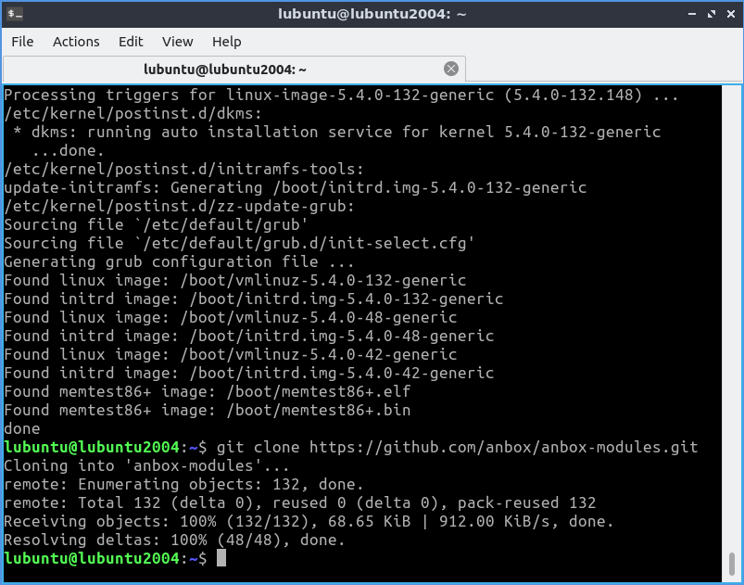

$ cd anbox-modules

$ sudo ./INSTALL.sh

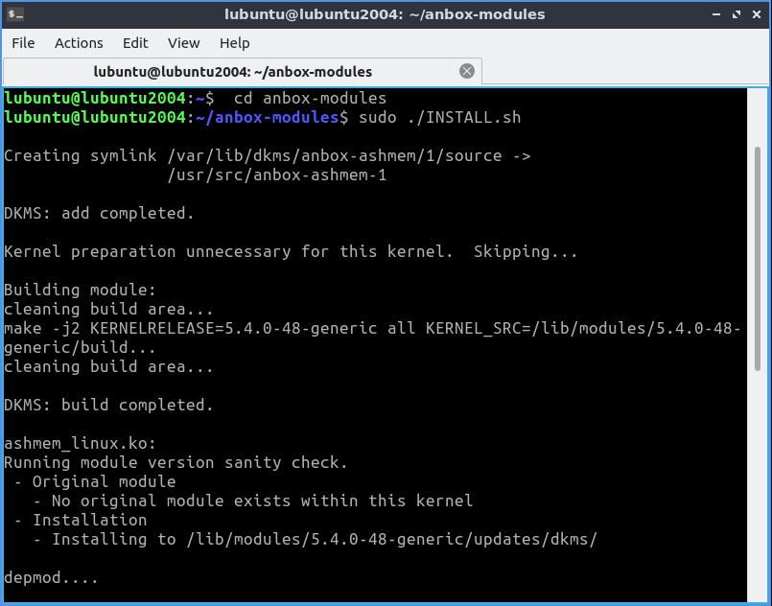

$ cd ..

$ sudo modprobe ashmem_linux && sudo modprobe binder_linux

$ ls -1 /dev/{ashmem,binder}

And you should see what is like the image below.

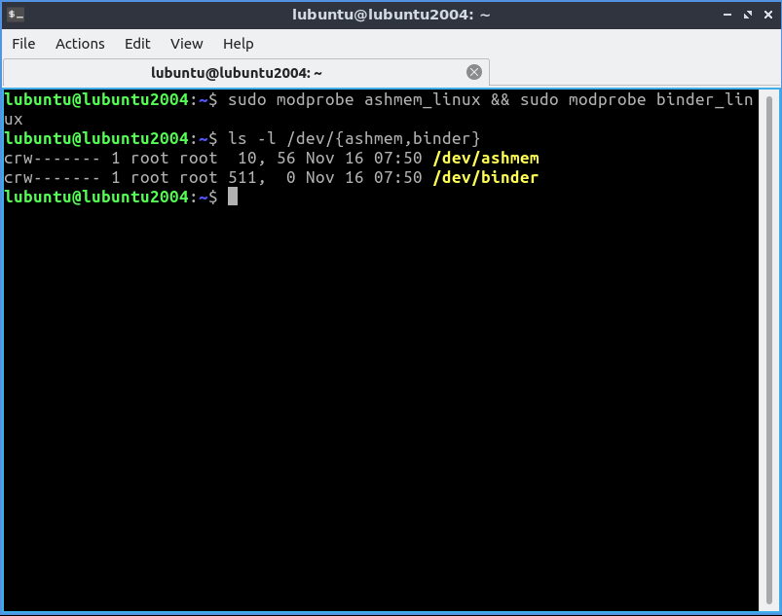

$ sudo snap install --devmode --beta anbox

Wait patiently until the installation of Anbox snpa is finished.

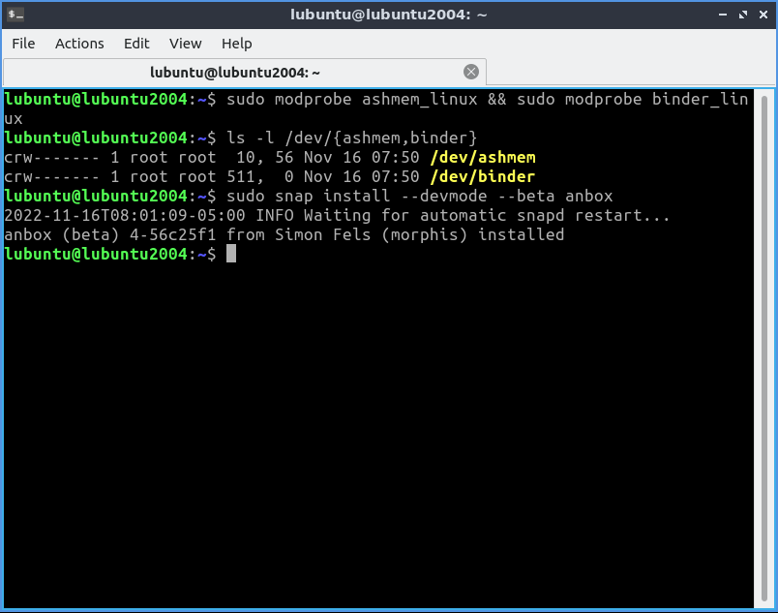

$ sudo snap refresh --beta --devmode anbox

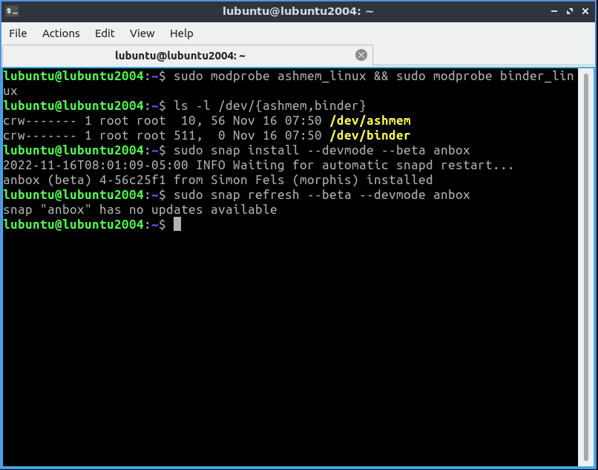

$ sudo apt install android-tools-adb

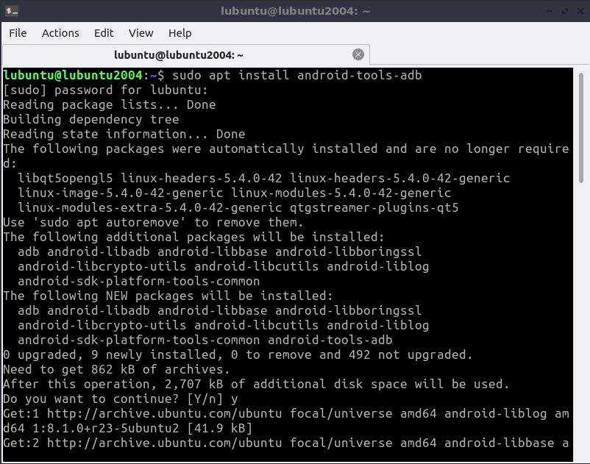

### 8.1.3 Installing our application

$ adb devices

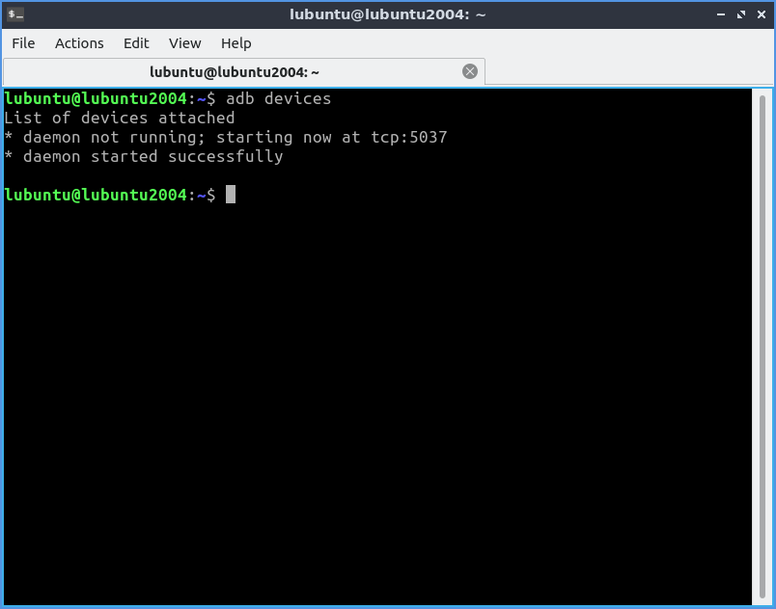

$ git clone https://github.com/unsw-cse-comp3900-9900-22T3/capstone-project-9900-w18q-commercialize.git

$ mv ./capstone-project-9900-w18q-commercialize/app-debug.apk .

$ mv ./capstone-project-9900-w18q-commercialize/french\ fries\ image.jpeg .

$ adb push french\ fries\ image.jpeg '/sdcard/DCIM'

Open the Start Menu of Linux, select “Other”->” Anbox Application Manager” to open Anbox. Wait for a few seconds to let it load, and you should see the image below.

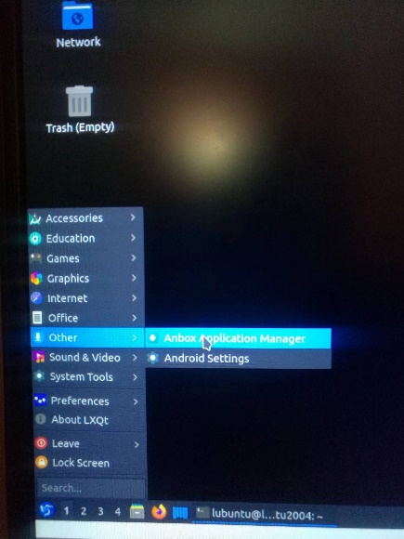

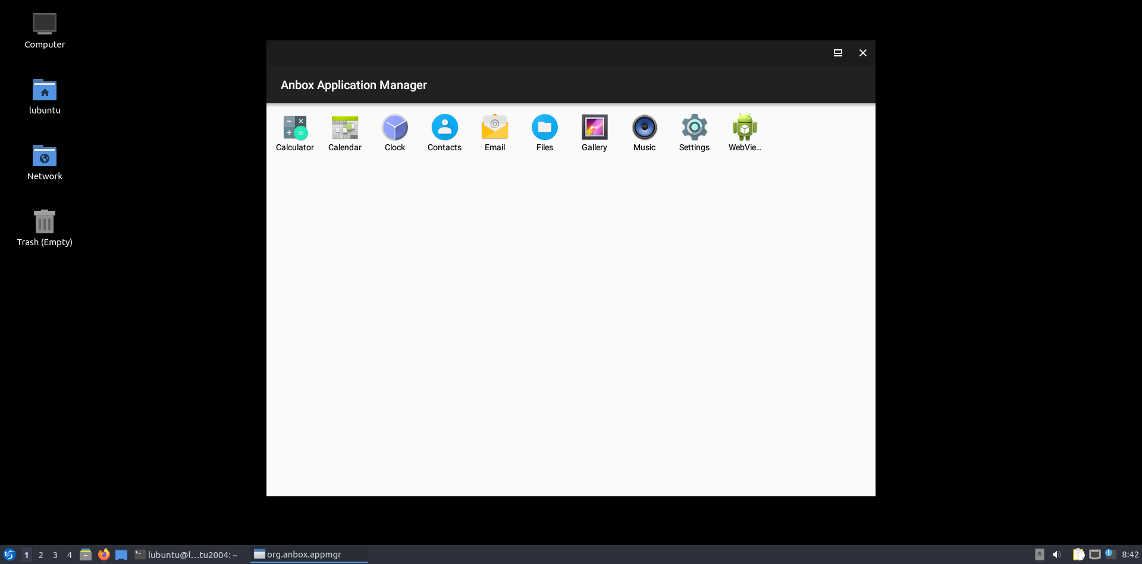

Keep Anbox open and execute:

$ adb install app-debug.apk

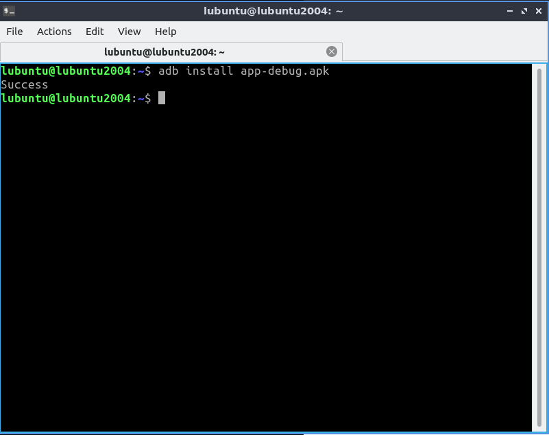

Now, our application has been successfully installed, and you can close Anbox.

## 8.2 Run the application

Everytime you run it, use the following two commands:

$ sudo systemctl restart snap.anbox.container-manager.service

$ anbox session-manager --single-window --window-size=393,795

Wait for a few seconds to let the Anbox be online.

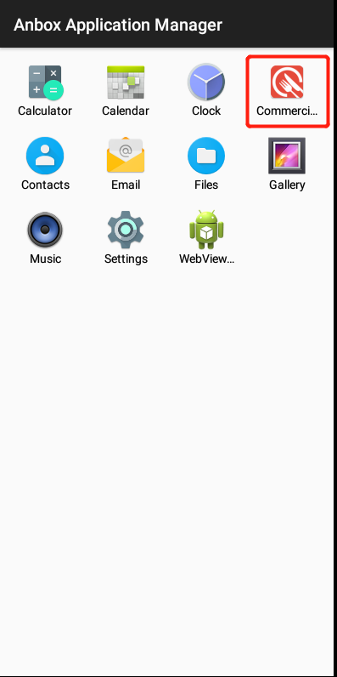

Click the icon of our APP to run it, you can try features we mentioned in this documentation.

**Please read IMPORTANT NOTES in 8.3 before you try.**

## 8.3 IMPORTANT NOTE

Anbox its own has some drawbacks that affect the performance of our application, and we have reported them to the Anbox officials for a fixing.

Here are five important things to note:

1. A bug in Anbox. Sometimes the content of a page may not be loaded and refreshed automatically when the progress bar of a circle stops rotating and the text of ‘Loading’ does not disappear. In this case, you need to hold the left button of your mouse and pull down this page a little bit to let the content appear. Refer to the image below.

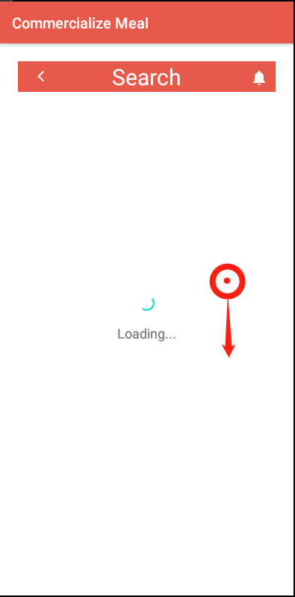

1. Since Anbox does not have a real navigation and status bar, you cannot try the feature of receiving a notification of new chatting messages when the APP runs on backstage.
2. Opening two emulators at the same time is not supported by Anbox. If you want to test the chat function, you can send a message to another user, then log out and sign in with that users E-mail and password to check whether he/she has received the message. If you want to confirm the chat is real-time, you need another virtual machine with this environment, then you can chat with each other.
3. An image of French fries has been uploaded to the gallery of Anbox, you can use it when trying to create a recipe. When you click “Add cover” on the Create Recipe page, you enter the Gallery of the Android system. The ‘back’ button of Gallery is invisible, you can close it by pressing the ‘Esc’ button on your keyboard.

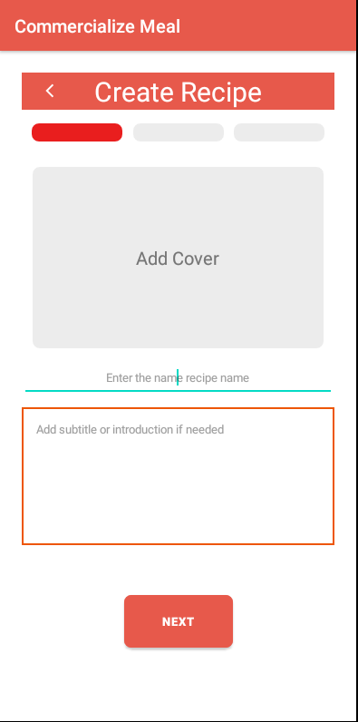 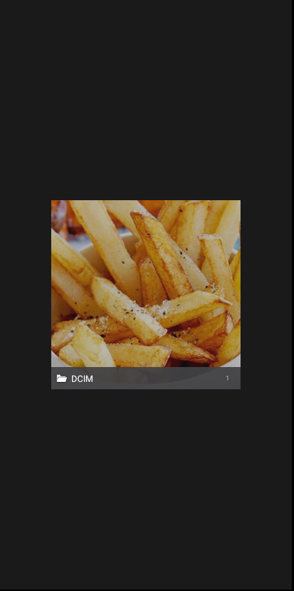

1. Every time you close the application or Anbox, please use the right-click ‘close’ button at the bottom of the screen, this may avoid some unforeseen issues.

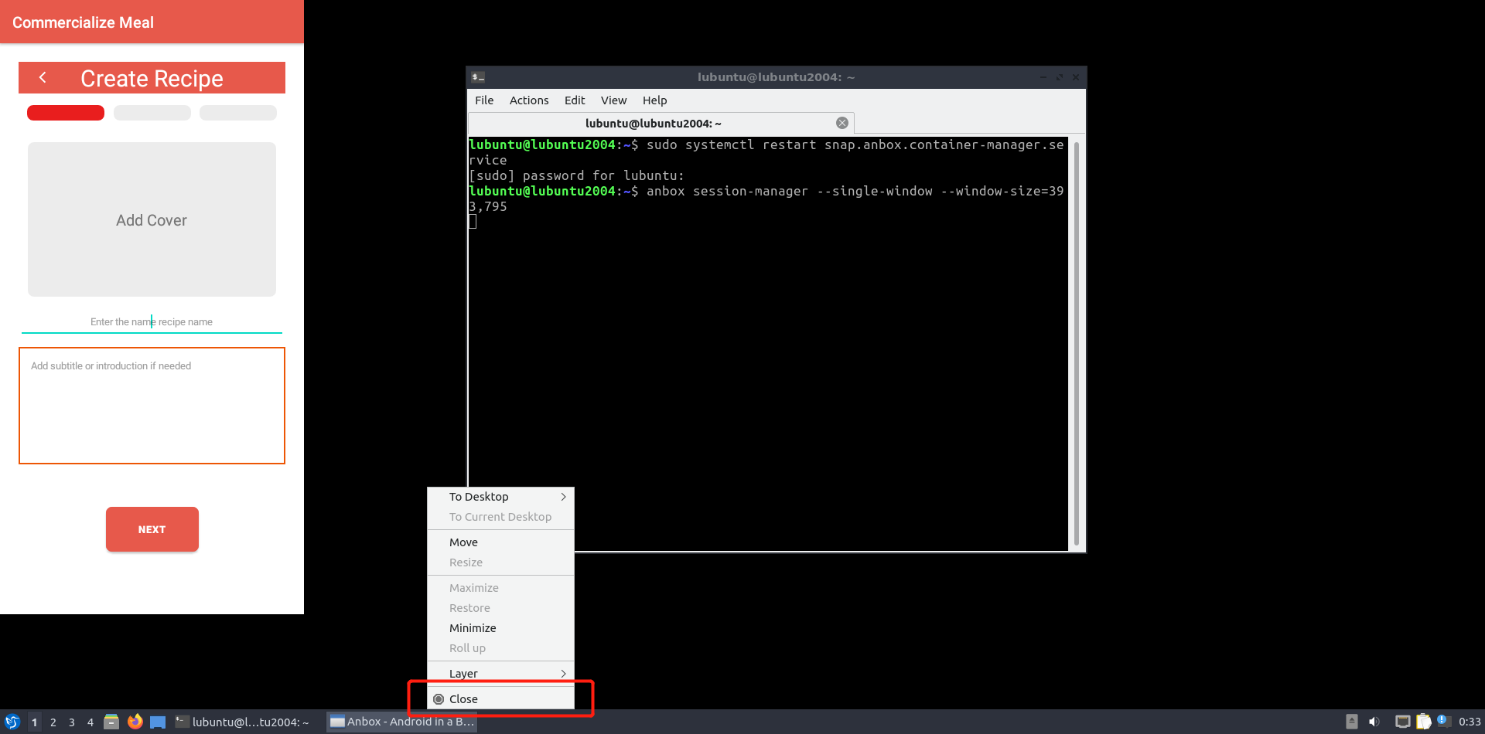

# 9 Reference

*Navigation: Android developers* *(2022) Android Developers.* Available at: https://developer.android.com/jetpack/androidx/releases/navigation (Accessed: November 15, 2022).

*Card view: Android developers (2018) Android Developers.* Available at: https://developer.android.com/jetpack/androidx/releases/cardview (Accessed: November 15, 2022).

*Multidex: Android developers (2018) Android Developers.* Available at: https://developer.android.com/jetpack/androidx/releases/multidex (Accessed: November 15, 2022).

*Firebaseui for Android - ui bindings for Firebase* (2022) *Firebase Open Source*. Available at: https://firebaseopensource.com/projects/firebase/firebaseui-android/ (Accessed: November 15, 2022).

Mi, V. (2016) *A fast ImageView that supports rounded corners, ovals, and circles.*, *GitHub*. Available at: https://github.com/vinc3m1/RoundedImageView (Accessed: November 17, 2022).

*Add build dependencies: android developers* (2022) *Android Developers*. Available at: https://developer.android.com/studio/build/dependencies#groovy (Accessed: November 15, 2022).

*Learn more about Android and firebase | Firebase for Android* (2022) *Google*. Google. Available at: https://firebase.google.com/docs/android/learn-more (Accessed: November 15, 2022).

*Add firebase to your Android project | Firebase for Android* (2022) *Google*. Google. Available at: https://firebase.google.com/docs/android/setup (Accessed: November 15, 2022).

*Google Analytics for Firebase* (2022) *Google.* Google. Available at: https://firebase.google.com/docs/analytics (Accessed: November 15, 2022).

*Set up a Firebase Cloud Messaging client app on Android* (2022) *Google*. Google. Available at: https://firebase.google.com/docs/cloud-messaging/android/client (Accessed: November 15, 2022).

*Retrofit* (2013) *Square*. Available at: https://square.github.io/retrofit/ (Accessed: November 15, 2022).

Panayiotis (2020) *Java fuzzy string matching implementation of the well known python's fuzzywuzzy algorithm. fuzzy search for Java, GitHub*. Available at: https://github.com/xdrop/fuzzywuzzy (Accessed: November 15, 2022).